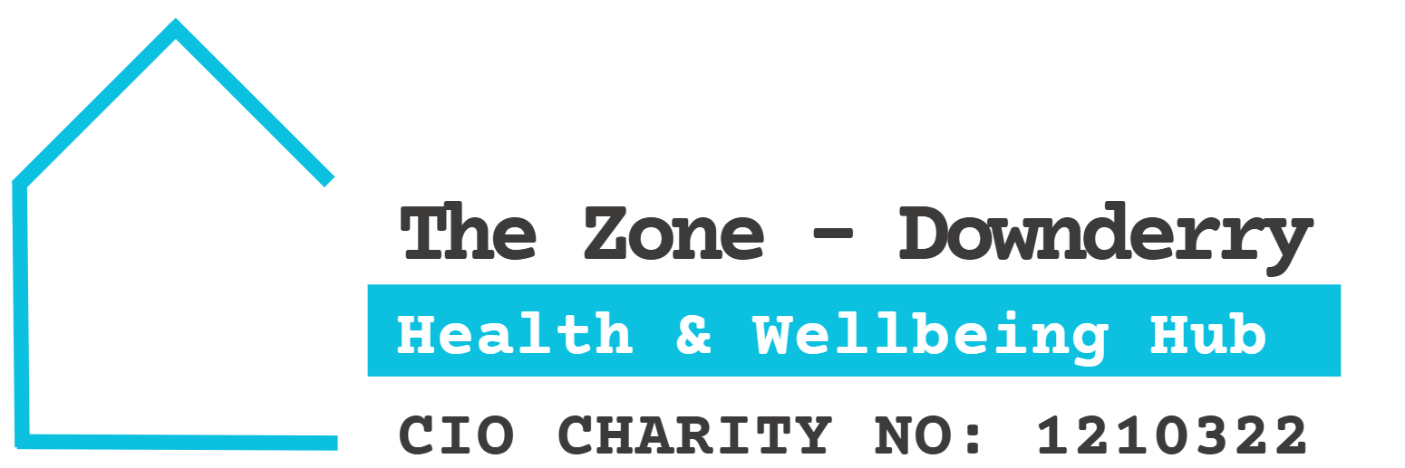

Volunteer Registration and Contact Details Form

Please Print
Name:
Address including Post Code:

Email address:

Contact phone number:

What specific areas would you like to volunteer to support:

Data Protection Policy
The Zone Health and Wellbeing Hub stores and processes personal data for the purposes of administration of the Charity. We do not share data with third parties. We occasionally publish data for the convenience of volunteers, such as telephone and email contacts. Members can request that their details be excluded from publication, by informing the Charity in writing.
By signing this form I agree to the Data Protection Policy
Signed: (participant)………………………………………Date:……………………………………………
Thank you for your offer of support
Trustees Zone Health and Wellbeing Hub

